DESIGN AND ANALYSIS OF GEARLESS 90 DEGREE TRANSMISSION USING FUSION 360

EDUNOJU SANJAY BHARGAV
17H51A0314
B.Tech Mechanical Engineering
CMR College of Engineering and Technology
esbhargav@gmail.com
A.HARISH
Mechanical Engineering
CMR College of Engineering and Technology

Abstract
A Gearless Mechanical transmission includes a housing which supports a high- speed shaft and a low-speed shaft along a main rotational axis. It includes a plurality of identical linkages, each having an off-center center of rotation, an input end and an output end. It is provided for transmitting rotational velocity from an input shaft to an output shaft without gears. The working of this arrangement is very smooth and work effectively with a very minimum amount of power losses, which is skillful and is having something precise in transmitting power at right angle without any gears being manufactured. The transmission includes an input shaft connected to a wedge. Both the input shaft and the wedge have rotational axes. The rotational axis of the input shaft is disposed at an angle with respect to the rotational axis of the wedge.
Keywords: Bearing, Shaft, Frame, Pully, Electric Motor, Cylinder
Introduction-
A transmission is a machine in a power transmission system, which provides controlled application of power. The term transmission properly refers to the whole drivetrain, including clutch, gearbox, prop shaft (for rear-wheel drive vehicles), differential, and final drive shafts. The most common use is in motor vehicles, where the transmission adapts the output of the internal combustion engine to the drive wheels. Such engines need to operate at a relatively high rotational speed, which is inappropriate for starting, stopping, and slower travel. The transmission reduces the higher engine speed to the slower wheel speed, increasing torque in the process. Transmissions are also used on pedal bicycles, fixed machines, and where different rotational speeds and torques are adapted.
Gearless transmission mechanism transmits power from input to output shafts by means of sliding links that form revolute pair with the hub. Links bent at required angle slide inside the holes in the hub. Thus, as the holes in input hub rotate; it pushes the links and in turn output hub is rotated. This mechanism can be used as a replacement for bevel gears in low cost, low torque applications. It can transmit at any angle between 0 to 180°
Bevel gears are generally used for transmission through non parallel shafts and worm and worm wheel and crossed helical gears are used for transmission through non parallel non intersecting shafts. These gears are costly to manufacture and come in standardized specifications thus limiting the flexibility of its application. So here we introduce gearless transmission mechanism which can transmit at any angle from 0 to 180°. The mechanism of made of input and output hubs with axial holes drilled along the pitch circle diameter and circular links bent at the angle between two shafts. So for a non- standard angle between shafts; only the angle of the links needs to be changed whereas the whole gear is needed to be redesigned in case of bevel gears. This reduces the cost of this mechanism drastically and also increases its flex
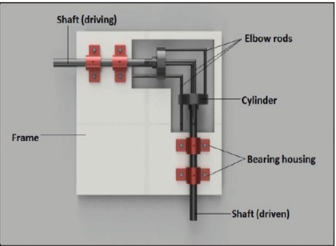
Fig-Gear less 90degree transmission
Power transmission for skew shafts is with the help of either crossed helical gear or worm gear or hypoid gears in a machine, but the manufacturing of these gear is very complex and power losses in gears due to sliding motion are quite frequent and the shaft orientations is very limited, so need arises for a better system. In Gearless power transmission for skew shafts which reduce the losses, cost & save the time and space. This system allows the changing in the orientation of shafts during motion which is very interesting and fascinating about this mechanism. In this transmission system no. of pins or links used must be odd (3,5,7,9...). Pins or links are fixed in the drilled holes at the both shaft ends due to which motion is transferred. The Working of this arrangement is very smooth & work effectively with a very minimum amount of power losses, which is skillful and is having something precise in transmitting power at right angle without any gears being manufactured. Gears are costly and complex to manufacture. It is needed to further increase the efficiency of transmission which cannot be done using geared transmission. Gearless transmission mechanism is capable of transmitting power at 90 degrees without any gears being manufactured. It is an ingenious link mechanism of slider and kinematic chain principle which transmits power at 90˚without utilizing gears.
COMPONENTS OF GEARLESS 90 DEGREE TRANSMISSION:
Gearless 90-degree transmission mechanism consists of various number of parts. The parts are given below:
bearing
shaft
frame
mechanical linkage
cylinder
BEARING: A bearing is a machine element that constrains relative motion to only the desired motion, and reduces friction between moving parts. The design of the bearing may, for example, provide for free linear movement of the moving part or for free rotation around a fixed axis; or, it may prevent a motion by controlling the vectors of normal forces that bear on the moving parts
SHAFT: A shaft is a rotating machine element, usually circular in cross section, which is used to transmit power from one part to another, or from a machine which produces power to a machine which absorbs power. The various members such as pulleys and gears are mounted on it
FRAME: We are design the frame to light weight material on the frame mounted the pedal and gear mechanism. The material used is aluminum-stainless steel.
MECHANICAL LINKAGE: A mechanical linkage is an assembly of bodies connected to manage forces and movement. The movement of a body, or link, is studied using geometry so the link is considered to be rigid. The connections between links are modeled as providing ideal movement, pure rotation or sliding for example, and are called joints. A linkage modeled as a network of rigid links and ideal joints is called a kinematic chain.
CYCLINDER- A cylinder is one of the most basic curved geometric shapes, with the surface formed by the points at a fixed distance from a given line segment, known as the axis of the cylinder. The shape can be thought of as a circular prism. Both the surface and the solid shape created inside can be called a cylinder. The surface area and the volume of a cylinder have been known since ancient times.
Literature review
- Somraj et al. [2017] Analyzed the Design and Fabrication of Gearless Transmission for Skew Shafts. 3 Nos. of L-pin rods were used. Overall mechanism is considered to be running on 0.25 HP motor with 140 RPM and Torque of 1238 N-mm. Design of Hub is done by Considering a hub of internal diameter is 32mm and outer diameter is 92mm, length is 82mm. Design of shaft was done by taking maximum tensile stress of 60 N/mm2and maximum shear stress of 40 N/mm2. Diameter of elbow rods was 8mm. It Was Concluded that given arrangement can be used for any set of diameters with any profile of shafts for skew shafts of any angle but the shaft’s must be having the rotational motion about his own axis, transmission of motion is very smooth and desirable and used only for the equal R.P.M. of driving shaft and driven shaft by employing links or given type of links for appropriate joints for revolute pair. It was also found that successful mechanical devices function smoothly however poor fly they are made while other does this only by virtue of an accurate construction & fitting of their moving parts.
R P Barot* and D M Patel[2020]-The present work mainly focuses on finding an alternate option of gear drives for various power transmitting applications in different sectors. In this study, the gearless power transmission mechanism created to transmit the power at various angles between the driving shaft and driven shaft, ranging from 0° to 180°. The system is modeled and analyzed in CREO5.0 to check the feasibility of the system. The speed analysis revealed that the speed ratio of the output shaft to the input shaft remained 1:1 during operation. The von mises stress analysis indicated that the design is safe under specific loading criteria. It observed from deformation analysis that the maximum displacement has occurred at the corner of the elbow link. The failure index analysis of the elbow link revealed that the inner curvature of a link is subjected to the maximum possibility of failure.
OBJECTIVES-
- The objective of the project is the design and analysis of a Gearless 90- degree transmission model while replacing the default material (AISI 430) of the elbow with other materials (Al 6061, Al 7075) and subjecting it to multiple loads for the evaluation of stress, deformation, factor of safety under static / structural analysis for the model.
- The design and analysis are done by using Fusion 360
METHODOLOGY-
The Gearless transmission assembles the input shaft and the output shaft with each other in a transmission system while eliminating the intermediate gears. Dimensions are approximated as a result this should be used only for demonstration purposes. Gear less transmission model is designed using Autodesk Fusion 360 software. Since the software is easy to design, it takes less time to sketch and create the parts. The designed parts are saved in cloud storage provided in the software itself. And the designed parts are assembled within the software and finally it is simulated within the software.
DESIGN PROCEDURE:
Designing parts individually
Assembly
Steps to assemble the parts of gear less 90-degree transmission are:
- Save all the parts to the cloud storage.
- Open new tab and drag all the parts into that tab.
- For multiple parts, use COPY command and place the parts in the tab.
- Start assembling the parts using JOINT command.
- Select the type of joint in the JOINT command box.
- Complete the assembly
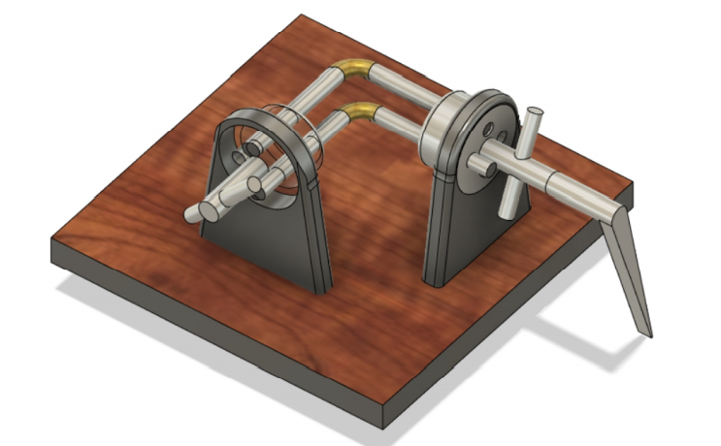Fig-Assembled Gear Less Transmissionn

SIMULATION AND ANALYSIS-
For analysis to be done, there must be a material to be applied. Material considered for this study is steel. This material is selected based on its physical properties. This material is applied and the loads are applied. The load acting is the force of the elbows when it is connected with cylinder. Since the elbows connects to the cylinders, all forces will act on it.
Structural constraints for the following component are shown below
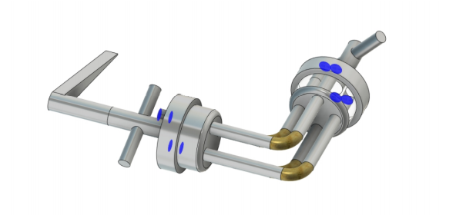
Elbow Material Selection - AISI 430(stainless steel grade 430) primary elbows material for producing.
1)AL 7075
2)AL 6061
3)AL 5052
4)AL 6063

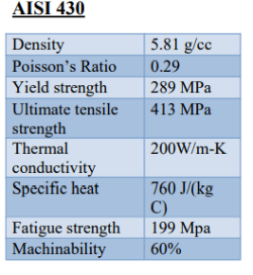
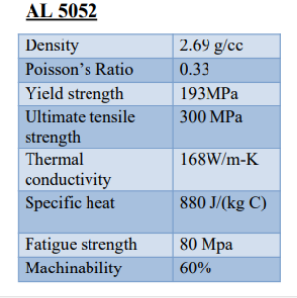
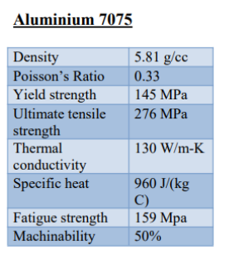
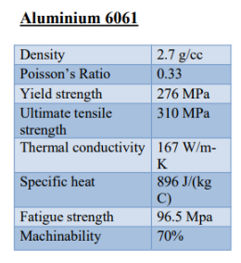
MESHING-
Meshing is helpful to transfer the loads from one place to another place, and here it has elements and nodes, and these elements and nodes play major role while transferring the loads from one place to another place.
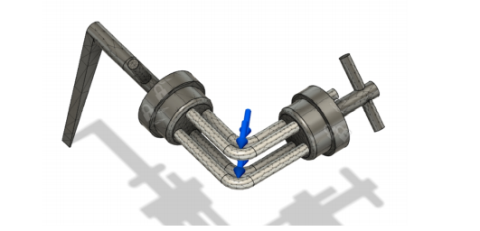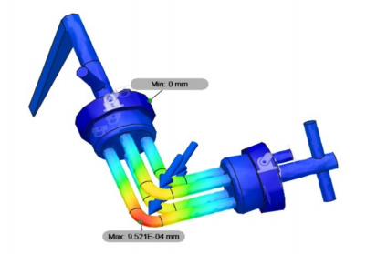
Comparing the values after the CAE analysis of each material
Material (elbow) is subjected to different loads at bends resulting in following performance (At 1000N load) please refer above fig

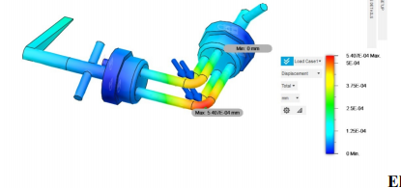

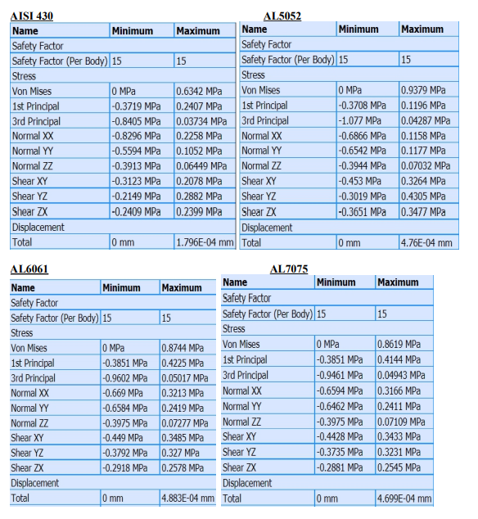

- At load 2000N force
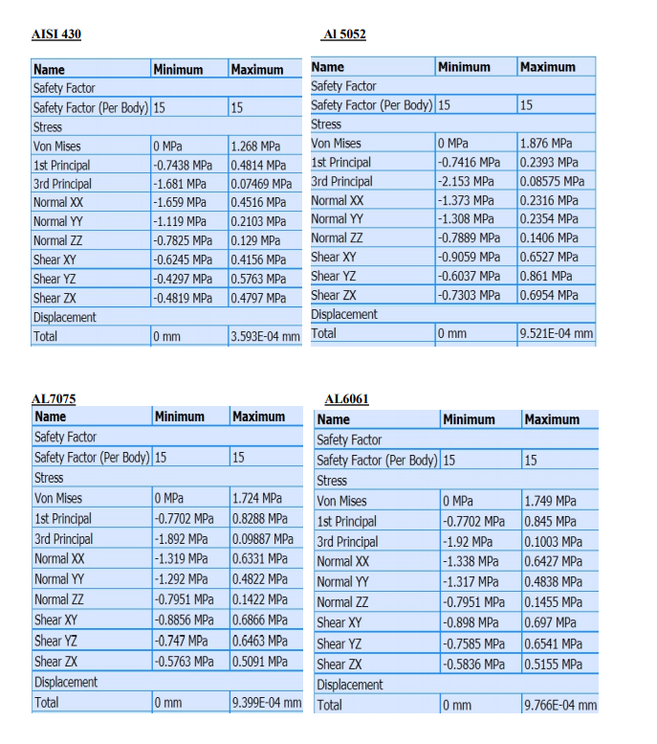

- At 3000 N force
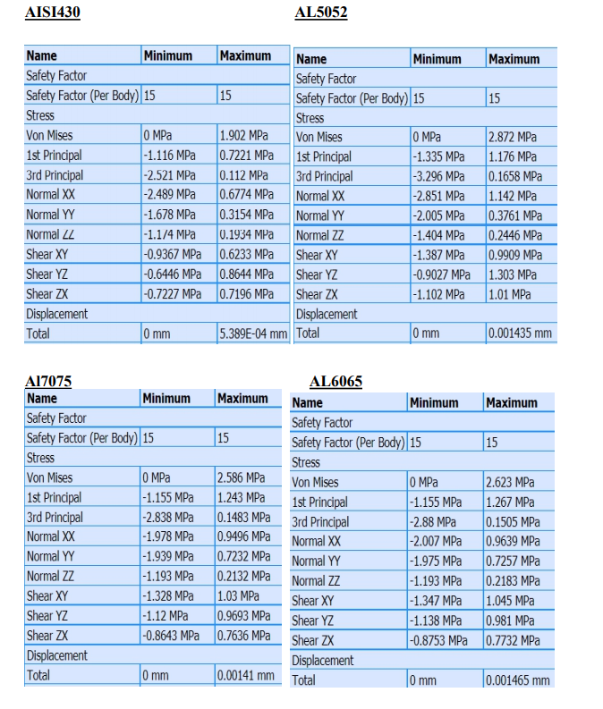

Due to high machining ability and high yield strength AL 7075 and AL6061 are further compared and the following charts represent the performances of each material values obtained from CAE analysis subjected to loads
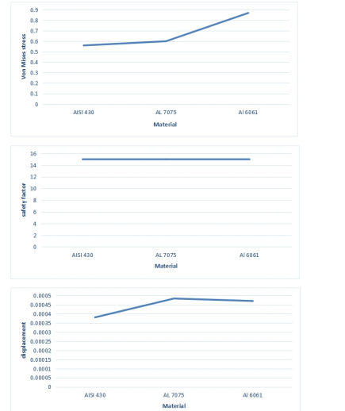
Aluminum 6061 has been selected for the manufacturing of elbow. It has high machine.
RESULTS
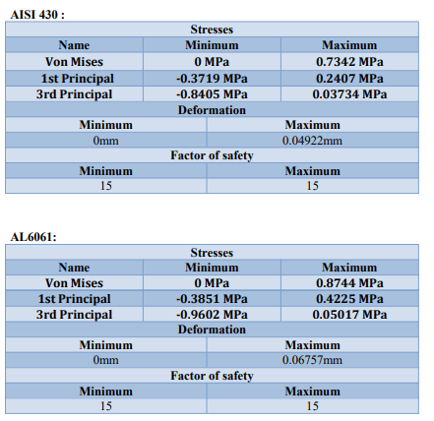
The following chart data states that with minimal deviation the primary material(AISI 430) and the optimum material AL 6061 both exhibit similar performances.
CONCLUSION-
Comparing the theoretical and analysis values of obtained for the elbow link in the mechanism, we can observe the different stress and displacement readings of the different materials under similar acting loads. This data can be used to understand the behavior of the materials at the working conditions at varying loads to check if the already existing choice of material (AISI 430) can be replaced with any other material; and if so, the replacement material can be selected on the basis of various working parameters. According to our study of analysis conducted by us, the materials AL 6061 and AL 7075 exhibit properties very close to the existing choice of material, but AL 6061 could be chosen as a viable replacement material for the member as it costs lesser and delivers almost same result

REFERENCES:
- “DESIGN AND FABRICATION OF GEARLESS POWER TRANSMISSION FOR SKEW SHAFTS” , by Prof R. Somraj, B. Sailesh, Apr –2017.•
- “Gearless Transmission Mechanism and its Applications” by Neeraj Patil, Jayesh Gaikwad, Mayur Patil, Chandrakant Sonawane, Shital Patel, March 2017. •
- “Multi-Angular Gearless Drive" , by Ashish Kumar, Puneet Pawar, Sagar Rana, Shishir Bist, July-2015.
- “DESIGN AND ANALYSIS OF GEARLESS TRANSMISSION THROUGH ELBOW MECHANISM” by Solanki Nehal Pramesh, Patel Harshil K, Singh Montu, Rajwani Avesh, March 2017.•
- “Design, Analysis and Fabrication of Gearless Power Transmission by using Elbow Mechanism”, by Shiv Pratap Singh Yadav, Sandeep G M, Rudra Naik, G C Keerthi Prakash, Gaurav Kulkarni, Hemanth Kumar S, Thalanki G Vamsi Krishna, April-2017. •
- “Analysis and Simulation of Gearless Transmission Mechanism", by Prof. B. Naveen Bardiya, T. Karthik, L Bhaskara Rao, September 2014. •
- “Gearless Power Transmission for Skew Shafts (A SRRS Mechanism)” by Amit Kumar and Mukesh Kumar, 2015. •
- “Design, Analysis and Fabrication of Gearless Transmission by Elbow Mechanism”, by Jagushte G. S, Kudalkar Hrishikesh, Patil Vikas, Varak Vishal, 2016. •
- “Gearless power transmission-offset parallel shaft coupling", by Prof. Mahantesh Tanodi, March 2014.

