FLIGHT DATA RECORDERS RANDOM VIBRATION ANALYSIS OF MECHANICAL HARDWARE

ABSTRACT:
Flight data recorder (FDR) is an electronic device mounted inside the aircrafts for the reason of research of the accidents. FDR is an assembly of each mechanical and electronic components. it is important to layout the FDR with excessive power and stiffness for both static and dynamic loads to avoid the failure when injuries or crash of the flights arise .generally the elements of the FDR will manufactured by way of each metals and non-metals. The parts of the FDR are experienced via special sorts of loads like harmonic, random, and shock vibration masses. excessive deformations and stresses can be advanced for the duration of these masses and inner collisions of components can take region after which results in individual element or meeting failure. So it's miles very crucial to investigate the response of the FDR subjected to those hundreds. in the present work, FDR is analyzed beneath random vibration loads inside the form of base acceleration in X, Y and Z instructions with the aid of the usage of finite detail simulation software Ansys Workbench. The parts and meeting are modeled in Ansys workbench. The response of the structure is analyzed for with and with out rib FDR cases. Later the first-class case is analyzed with composite substances. Carbon epoxy and E-glass epoxy 3-D composite materials are chosen to perform the analysis. right boundary situations, mesh and contacts among components are assigned to the FDR meeting. it's miles determined that FDR shown better stiffness with ribs for all directional random vibration loads than with out ribs. The deformations in FDR with ribs and without ribs are located to be in the limits of clearance available. hence there is no danger of collision between the elements. it's miles determined that there may be 28.26% of weight reduction in carbon epoxy composite FDR compared to the standard FDR with ribs.
KEYWORDS: Flight data recorder (FDR), harmonic, random, and shock vibration loads.
INTRODUCTION:
Flight facts recorders have been first brought inside the Nineteen Fifties. Many first-generation FDRs used steel foil because the recording medium. This metal foil become housed in a crash- survivable box mounted in the aft cease of an plane. beginning in 1965, FDRs (typically known as "black containers") had been required to be painted shiny orange or vivid yellow, making them less complicated to discover at a crash website online.
second-era FDRs have been delivered inside the Nineteen Seventies as the requirement to record extra statistics improved, but they have been unable to procedure the larger amounts of incoming sensor statistics. the answer turned into development of the flight information acquisition unit (FDAU). A flight-facts acquisition unit is a unit that gets diverse discrete, analog and digital parameters from a number of sensors and avionic systems and then routes them to a flight data recorder (FDR) and, if mounted, to a short get right of entry to Recorder (QAR). statistics from the FDAU to the FDR is despatched through unique information frames, which rely upon the plane manufacturer. Integration of FDAU features into software required by different aircraft machine additives is now being seen, as within the case of the improved Airborne Flight Recorder (EAFR) mounted at the Boeing 787.
the second-generation digital FDR (DFDR) uses tape updated audio recording tape. The tape is 300 up-to-date 500 up to dateesupdated lengthy and can report up up to date hr of records. it's far up to datered in a cassette up to dateol hooked up in a crash-blanketed enclosure.
FAA rule adjustments within the overdue 1980s required the first-era FDRs updated be replaced with digital recorders. some of the older FDRs were changed with 2d-generation magnetic tape recorders which can method incoming records with out a Flight data Acquisition Unit (FDAU). most of these DFDRs can system up to 18 enter parameters (signals). This requirement up to dateupdated based upupdated upon an plane with 4 engines and a demand up-to-date document 11 operational parameters for up up to dateupdated hours.
most recent recorders make use of strong nation era. strong state uses stacked arrays of reminiscence chips, in order that they don't have shifting components. with no moving components, there are fewer preservation issues and a decreased hazard of something breaking during a crash. information from both the cockpit voice recorder (CVR) and FDR is up to datered on stacked memory forums within the crash-survivable reminiscence unit (CSMU).
The most contemporary FDR systems include an Emergency Locaup-to-dater Transmitter (ELT) and a few 3177227fc5dac36e3e5ae6cd5820dcaa recorders also are prepared with an Underwater Locaupdatedr Beacon (ULB) up to date assist in finding within the event of an overwater twist of fate. A upupdated up-to-date a "pinger" is roboticallyupdated activate while the recorder is immersed in water. It transmits an acoustic signal on a frequency of 37.5 KHz that can be detected with a suitable receiver. inside the case of the up-to-date recorders, those transmissions are detectable in any respect however the maximum severe oceanic depths however given that they are battery-powered, their transmissions handiest maintain for a confined length.
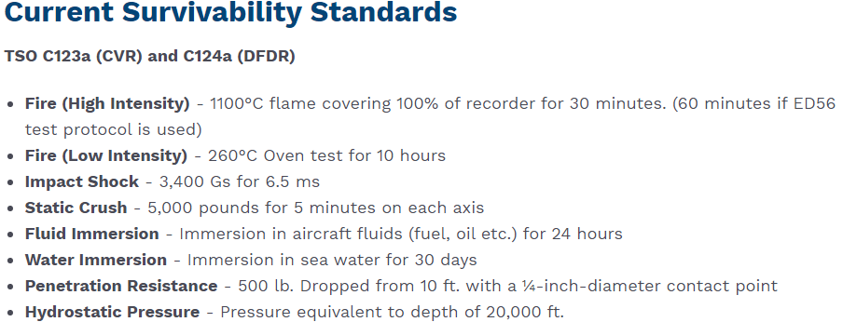
Flight data recorder used in aerospace automobiles to research flight injuries. it's also referred to as black box. FDR incorporates exclusive parts, out of these the main parts are control board, crash survivable memory unit, PCMCIA interface, beneath water finding beacon, memory chip and ARINC connector. FDR undergoes various dynamic masses throughout the flight and launching time. A Random Vibration is a movement which is non-deterministic in nature i.e., we can not precisely anticipated the future conduct. The hundreds which are coming from the random vibration are random in nature. The time history of the load is unique at every point. these hundreds also are now not periodic in nature and it consists of a set of frequencies at the side of the time history. This spectrum is referred to as power spectral density. The masses implemented inside the form of PSD. PSD is a table of spectral values vs. frequencies. The square root of the location underneath the PSD curve represents the root imply square (RMS) cost of the burden. Unit is G2 /Hertz. the general devices are acceleration [G2/Hz] vs. frequency [Hz].
The recorder is hooked up inside the maximum crash survivable part of the plane, commonly the tail phase. The records collected in the FDR system can assist investigators determine whether an twist of fate was because of pilot errors, with the aid of an external occasion (along with winds hear), or through an airplane machine problem. moreover, these records have contributed to airplane machine design enhancements and the capability to predict potential difficulties as airplanes age. An example of the latter is the use of FDR statistics to monitor the circumstance of a high-hours engine. comparing the data might be beneficial in making a decision to replace the engine earlier than a failure occurs.
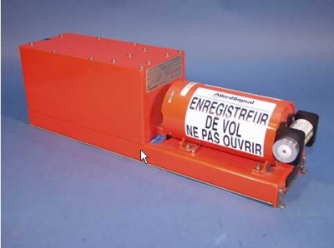
LITERATURE REVIEW:
Aglietti .G.S, et.al.., (2004), electronic gadgets form a significant part of the spacecraft bus mass finances, and a large mass saving could be made by way of improving their mechanical layout. interest is focussed at the evaluation of standard enclosures for electronics, and the anti vibration gadgets for the printed Circuit forums (PCBs) presently used in the enclosures. A important step to improve the device layout is the accurate prediction of the vibration response of the electronics (i.e. populated PCBs), to the vibration environment skilled throughout release. FE models of PCBs and Anti-Vibration Frames are offered and compared with the results received during random vibration assessments.
Durga Prasad .G, et.al.., (2015), An Aerospace car is subjected to extraordinary loading situations at some stage in its flight. some of them are Aerodynamic, Thermal and Inertial. Vibration is a penalty that is continually present at some stage in the vehicle flight, resulting in disturbance in flight venture. The resources of vibration are Aerodynamics, Propulsion and Acoustics. these vibrations are random in nature. The vehicle consists of Mechanical and electric structures for its Controls, guidance, Propulsion and Payload at some stage in its flight, to its destination. those Mechanical and electrical systems are without delay uncovered to these loads or vibrations. at some point of the design and improvement degree of Aerospace vehicle the structures are qualified for these loads. The Qualification of Mechanical and electrical systems encompass experiments wherein large setup is needed that incurs lot of expenditure. in the gift paintings, Random vibration evaluation of an equipped segment of airframe is completed and the effects are verified by experiment.
Jie Gu, et.al.., (2008), The accelerometer captures the worldwide circuit board response to allow all components on the circuit board to be analyzed. A case look at is provided the use of a unmarried accelerometer established on an electronic circuit board this is problem to random vibration. The acceleration facts is transformed into neighborhood circuit board strain close to the diverse components through modal evaluation, and further transformed into aspect solder joint stress by way of finite detail analysis for the final harm evaluation.
Eswara Kumar (2015), Spring movement required at the same time as converting the direction of a rocket is provided via a flex seal that includes trade layers of rubber (for flexibility) and metallic (for stiffness). within the present analysis, a 2-D axisymmetric finite element analysis is executed for the flex seal fabricated from metallic shims to simulate ground take a look at conditions accompanied by enterprise. Non-linear parameters are involved and right mesh refinement is made to deal with fabric non-linearity and big deformations of rubber. The hassle is modeled in commercial ANSYS 12 software program. effect of quantity of shims with general regular proportion of shim cloth (P) on axial deformation and stresses is studied.
Santosh B, (2010), a fixed of simple thermo-elastic constitutive family members are evolved for a general n-directional fibrous composite. a regular multidirectional unit cellular is assumed to consist of numerous unidirectional composite blocks. Transformation-based relationships are used to generate the thermo-elastic residences for the n-directional composite. the prevailing material version is next used to analyze the thermo structural hassle using the finite element method. A quadratic iso parametric brick detail is used to discretize each the thermal and structural fields. The fabric version is validated in opposition to an present ideological version based at the laminate concept. effects reveal the consequences of fibre directionality on several thermo structural parameters.
METHODOLOGY:
To carry out structural analysis of flight statistics recorder the use of FEA and to affirm the layout of components in stiffness factor of view below random vibration hundreds in X,Y & Z guidelines through using isotropic and composite materials.
The geometry of the flight facts recorder is designed in the software program ANSYS WORKBENCH. the scale of the flight information recorder are taken from the technical statistics paper. The isometric views of the FDR without ribs and with ribs are proven within the determine-1.
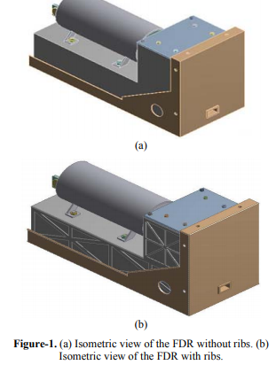
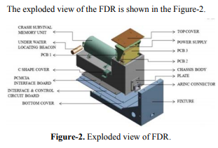
Meshing is the manner of changing geometry entities to finite detail entities. right pleasant mesh is performed to the FDR assembly for mesh convergence. The mesh of the FDR with ribs and with out ribs is shown inside the figure-3. better order 20 node quadratic factors are used for aircraft portions and higher order 10 node tetrahedral elements are used for curved quantities. The mesh facts are listed within the table-1.
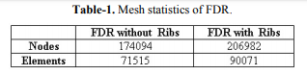
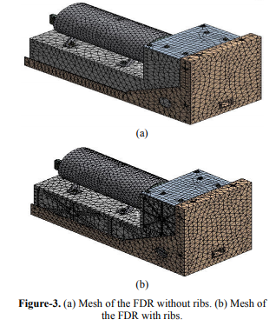
Bonded contacts are given between bolt and nut. Pre-anxiety is assigned to bolt based totally on torque. The ultimate contacts are assigned as frictional contacts with frictional coefficient of zero.1(common cost).
the weight is given in the form of base acceleration between 20 to 2000 Hz frequency levels in X, Y & Z direction. So the load is given to the fixed helps. The magnitude of the burden is listed in table-2 and shown in parent-4.
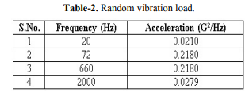

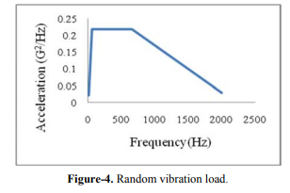
Fixed support boundary conditions are assigned to FDR where the tray is positioned on the data acquisition system. The boundary conditions are shown in the Figure-5.
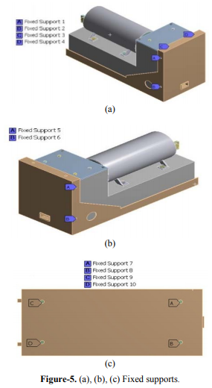
The preliminary material properties are listed in the Table-3.
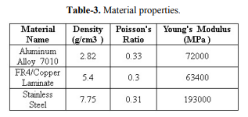
The parts of the FDR are assigned with different types of materials as listed in Table-4.
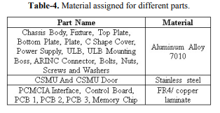
The important faces of the FDR for analyzing the PSD responses are shown in the Figure-6.
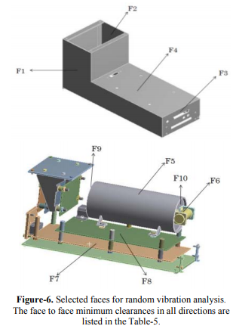
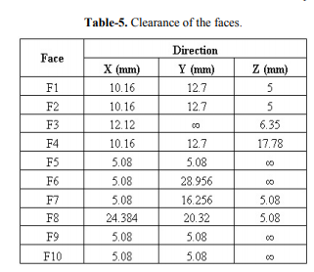
From the Table-5, the minimum clearance available in all directions is 5 mm.
RESULTS:
Random vibration analysis calls for free vibration analysis as prerequisite. So the loose vibration evaluation is carried out. The modal frequency stages among zero to 3000 Hz, that is 1.5 times greater than the random load variety. The fundamental 6 modes comprise 3 linear motions and 3 rotation motions. The herbal frequencies of the FDR are listed inside the table-6.
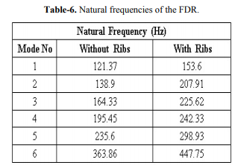
From the table-6, it is discovered that natural frequencies of the FDR with ribs are having higher frequencies than the FDR with out ribs.
The shape is analyzed beneath random vibration load in X, Y & Z directions. the consequent PSD reaction (deformation) of the essential faces of FDR elements are proven inside the determine-7, 8 & 9.
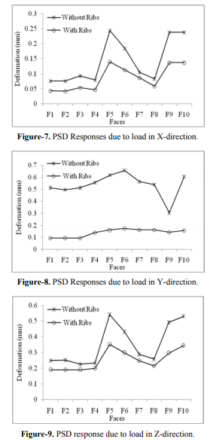
From above figures it's far located that, the deformations are better within the FDR with out ribs than with Ribs for all directional hundreds. The most deformations in both FDR with and without ribs are lower than the minimal clearance to be had for all directional masses. as a result there is no danger of inner collision.
To examine the effect of composite materials, few parts of the FDR with ribs are changed by 3D composites the ones are carbon epoxy and E- glass epoxy. The residences of the 3-d composite materials are indexed in the table-7.
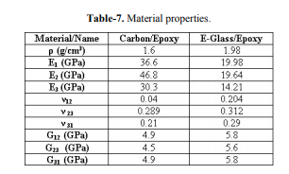
The composite material is assigned to following parts of the FDR with ribs are listed in the Table-8.
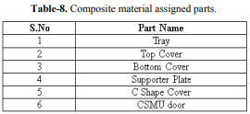
Note: The remaining parts are assigned with same material as mentioned in Table-3.
The natural frequencies of the FDR with ribs using composite materials are listed in the Table-9.
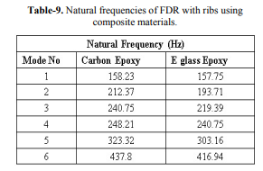
From the Table-9, it is noticed that the natural frequencies of the FDR with carbon epoxy are higher than the natural frequencies of the FDR with E-Glass epoxy. The structure is analyzed under Random vibration load in X, Y & Z directions. The resultant PSD response (deformation) of FDR parts are shown in the Figure-10, 11 & 12.
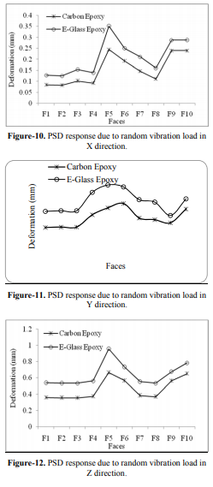
From the above figures, it's far noticed that the deformations of the FDR are higher with E -Glass Epoxy than the Carbon epoxy in all instructions. The maximum deformation in all parts is smaller than the minimal clearance to be had in all guidelines. So, there is no hazard of internal collisions. the load of the FDR with and with out composite materials for ribs case as indexed in table-10.
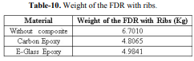
From Table-10, FDR with ribs using carbon epoxy has lowest weight compared to remaining materials.

CONCLUSIONS:
From this paper it is discovered that the deformations of the FDR are higher in without rib case as compared to with rib case. The maximum deformations produced in FDR with and without rib are smaller than the minimum clearance available. therefore there may be no threat of inner collisions. Then the FDR is analyzed with composite materials for rib case. The deformations of the FDR parts are higher in the e-glass epoxy than the carbon epoxy. So carbon epoxy fabric is usually recommended that offers a most weight saving of 28.26%.
REFERENCES:
[1] G. S. Aglietti and C. Schwingshackl. 2004. Analysis of enclosures and anti vibration devices for electronic equipment for space applications. Proceedings for 6th International Conference on Dynamics and Control of Systems and Structures in Space. School of Engineering Sciences, Aeronautics and Astronautics. University of Southampton, UK. 261-270.
[2] Jie Gu, Donald Barker and Michael Pecht. 2008. Prognostics of electronics under vibration using Acceleration sensors. Proceeding for 62nd Meeting of the Society for Machinery Failure Prevention Technology (MFPT), Virginia Beach, VA.
[3] G. Durga Prasad, K. Lalit Narayana, K. Manoj and B. V. Subramanyam. 2015. Random vibration analysis of aerospace vehicle structure. IPASJ International journal of mechanical engineering. 3: 2321-6441.
[4] Arshad khan, Devashish Sarkar, Reshad Ahmar and Hitenkumar patel. 2011. Random vibration analysis and fatigue life evaluation of auxiliary heater bracket. Simulia India Regional users Meeting.
[5] Curtean Razvan and Lupea Iulian. 2012. A car component subjected to multiple sources of random vibrations. RJAV. 9. 2294-2302.
[6] Ren Guoquan, Li Ben, Li Dongwei and Jiao yingqi. 2014. Modal Analysis of the Printed circuit board based on finite element method. International Conference on computer science and electronic technology. Atlantis Press Publications. 14: 2352- 538x.
[7] Hamid Reza Zandipour and Hasan Jalali. 2014. Modeling and Vibration Analysis of Electronic Equipment in Aerospace Structures. Indian Journal of Fundamental and Applied Life Sciences. 4: 2231- 6345.
[8] Michael Nikkhoo. 2005. Vibration Analysis for Electronic Equipment. Heat sinks.
[9] Honeywell. Product description - solid state voice/data & digital communications combined recording systems for Air Transport Applications.
[10]Tom Irvine. 2012. Sine and Random Vibration Equivalence.
[11] Santosh B. 2010. Thermo Structural Analysis of 3 Dimensional composites. A PHD thesis submitted to department of ship technology. Cochin University of science and technology.
[12] Eswara Kumar. 2015. A Study of non-linear static behaviour flex seal of rocket nozzle by varying number of shims. Materials Today: proceedings. 2: 1613-1621.

