A LITERATURE SURVEY ON FRIENDBOOK RECOMMENDATION SYSTEM THROUGH LIFE STYLE

BADARABOINA PRASAD,
M.Tech (CSE),
Department of Computer Science Engineering,
NRI Institute of Technology
MURUKUTLA HANUMANTHARAO
Assistant Professor,
Department of Computer Science & Engineering,
NRI Institute of Technology

Abstract
Presently all social sharing networking sites like Facebook,Twitter, Google+ recommending friends based on navigation instead of personal attitude will not , that can`t replicate users’ reality preferences on friend selection. In this paper, we present a life style primarily based on friend recommendation system for social networks that recommends friends to users supporting their life designs rather than social graphs. By exploiting sensor-rich smartphones, this technique makes an endeavor to derive life kinds of users by exploitation data obtained from sensors that's terribly user-centric. It, in addition measures the similarity of life styles between users, and recommends friends to users if their life styles have high similarity. It permits users to talk with friends. Friendbook expose life styles of users from usercentric sensor data, measures the similarity of life styles between users, and advice the friends to users if their life styles have high similarity .We further propose a similarity metric to measure the similarity of life styles between users, and calculate users’ impact in terms of life styles with a friend-matching graph. Upon receiving a request, Friendbook gaincoming a list of people with highest recommendation scores to the query user. Finally, Friendbook integrates a feedback mechanism to further improve the recommendation accuracy.
Keywords - Data Mining, Friend Recommendation, Sensors, Android, Smartphones, Machine Learning, Lifestyle.
INTRODUCTION:
A social network is a system where users (nodes) are joined with one another by relationship (edges). The edges are undirected and the quantity of edges demonstrates the quantity of companions a user’s has. A percentage of the remarkable interpersonal organizations are Facebook, Google plus LinkedIn and so forth. Each client keeps up a profile. There are numerous properties in the profile which can be utilized to anticipate the quality of ties between diverse users. In particular, this “shopping” way of living mostly consists of this “walking” exercise, however might also secure the “standing” or this “sitting” pursuits. To style everyday lifestyles adequately, we all bring an analogy in between people’s everyday lifestyles along with papers. Existing social networking services recommend friends to users based on their social graphs, which may not be the most appropriate to reflect a user’s preferences on friend selection in real life. Prompted through this particular, likewise, we can address our everyday lifestyles (or lifestyle documents) seeing that a number of standards of living (or topics), along with every single way of living seeing that a number of pursuits (or words). The vast majority of the friend advise system depends on previous users connections to pick friend candidates. For example, Facebook depends on a social connection examination among the individuals who as of now impart basic friends and suggests symmetrical users as potential friends. Existing social networking services prescribe friends to users based on their social graphs, which may not be the most appropriate to reflect a user’s favorites friend selection in real life. With the quick advancement of social network, approval systems in different fields design. A decent suggestion framework must be combine different sorts of suggestion impacts and assurance differences on the base of precision, in order to fulfill some disagreeable tastes.. According to current news Facebook is trying to develop algorithm, to understand user behavior. Social Networking sites can help us in getting important information of users, such as age, gender, location, language, actives, likes etc. our model takes into account these parameters of the user to recommend books. Most of the friend suggestions mechanism relies on pre-existing user relationships to pick friend candidates. For example, Facebook relies on asocial link analysis among those who already share common friends and recommends symmetrical users as potential friends. The rules to group people together include: 1) Habits or life style 2) Attitudes 3) Tastes 4) Moral Standards 5) Economic level; and 6) People they already know. Apparently, rule #3 and rule #6 are the mainstream factors Considered by existing recommendation systems.
LITERATURE SURVEY
Recommendation systems can be divided into two areas of focus: object recommendation and link recommendation. Companies such as Amazon and Netflix emphasize object recommendation where products are recommended to users based on past behavioral patterns. Social networking sites such as Facebook and LinkedIn focus on link recommendation where friend recommendations are presented to users. The work we present in this paper focuses on the latter, in which we develop friend recommendations within social networks. The recommendation algorithms employed by sites such as Facebook are proprietary. However, through observation, it is apparent that a friend of friends approach is being used. This approach is useful and efficient due to ease of implementation and the nature for humans to be drawn together through association approaches such as graph based induction and link mining have been considered but fall in comparison to the effectiveness and efficiency of a friend of friends approach. Study of few recommendation pattern used by websites: Amazon recommendations change regularly based on a number of factors.
The development of social networking systems, friend recommendation has become a lot of consideration. The existing friend recommendation in long range social networking systems, e.g., Facebook and Twitter, suggest friends to user’s if, as per their social relations, they report common friends. In the temporary, other proposal components have additionally been proposed via analysts. Another Suggestion based on geologically related friends in social network by joining GPS data and social network structure. . The main steps that required to be handling the anti-phishing are the following: (1)Pattern Rrecognition: pattern recognition techniques in the agricultural domain. A unique and proper combination of pre-processing, feature extraction, feature selection and classification process is required for each domain or problem in order to optimize accuracy, speed and reduce cost by minimizing feature set used for training and classification. The theories behind pattern recognition are presented at the beginning and a review of different techniques applied in grading, remote sensing, diseases detection etc.is provided as part of the evolution (2)Page Rank :Page Rank incrementally for evolving graphs. The key observation is that evolution of the Web graph is slow, with large parts of it remaining unchanged. By carefully delineating the changed and unchanged portions and the dependence across them, it is possible to develop efficient algorithms for computing the Page Rank metric incrementally. (3)Recommendation Techniques : Recommendation techniques developed or proposed till now. Various categories in which recommendation algorithms can be classified are discussed above. Also various open source graph processing platforms are discussed in detail. (4)Friend matching graph :It is a weighted undirected graph G=(V,E,W) where V represents users, Edge represents relationship and Weight represents similarity between users. At a time only 5-10 recommendation are made to the user. outcome of an anti-phishing technique depends on recognizing illegal websites and within moderate span of time. Even though a number of anti-phishing solutions are designed, most of these solutions were unable to make highly accurate decisions causing a rise of false positive decisions, which means labelling a legitimate website as fake. We focus on technical solutions proposed by scholars in the literature.
PROPOSED SYSTEM
Our proposed system addresses the problem of computing large amount of data and scalability. In our proposed method, we use incremental computation of Page Rank, can be implemented incrementally (or) distributively for large scale evolving graphs. Additionally, we propose a novel algorithm, Weighted Page Rank algorithm which distributes rank score based on popularity of the pages and we set threshold for each edge & it can represent the similarity relationship of friend-matching graph. We also have implemented Hex Converter to efficiently secure the password of the users. Friend book returns a list of people with highest recommendation scores to the query user. Finally, Friend book integrates a feedback mechanism to further improve the recommendation accuracy. Existing social networking services recommend friends to users based on their social graphs, which may not be the most appropriate to reflect a user’s preferences on friend selection in real life. In this paper, we present Friendbook, a novel semantic-based friend recommendation system for social networks, which recommends friends to users based on their life styles instead of social graphs. By taking advantage of sensor-rich smart-phones, Friendbook discovers life styles of users from user-centric sensor data, measures the similarity of life styles between users, and recommends friends to users if their life styles have high similarity. Inspired by text mining, we model a user’s daily life as life documents, from which his/her life styles are extracted by using the Latent Dirichlet Allocation algorithm. We further propose a similarity metric to measure the similarity of life styles between users, and calculate users’ impact in terms of life styles with a friend-matching graph. Upon receiving a request, Friend-book returns a list of people with highest recommendation scores to the query user. Finally, Friend-book integrates a feedback mechanism to further improve the recommendation accuracy. We have implemented Friend-book on the Android-based smart-phones, and evaluated its performance on both small-scale experiments and largescale simulations. The results show that the recommendations accurately reflect the preferences of users in choosing friends.

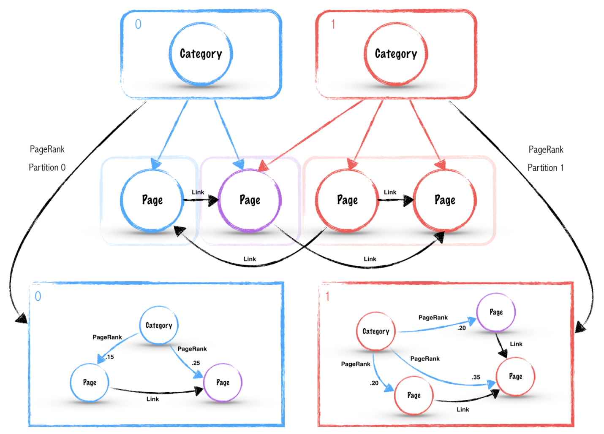

Fig:1 Semantic Friendbook recommendation:
Note that the work in this paper is significantly different from our preliminary demo work of Friendbook recommended friends to users based on the similarity of pictures taken by users. Activity Recognition To derive pðwi j dkÞ, we need to first classify or recognize the activities of users. Life styles are usually reflected as a mixture of motion activities with different occurrence probability. Therefore, two motion sensors, accelerometer and gyroscope, are used to infer users’ motion activities. Generally speaking, there are two mainstream approaches: supervised learning and unsupervised learning. For both approaches, mature techniques have been developed and tested. In practice, the number of activities involved in the analysis is unpredictable and it is difficult to collect a large set of ground truth data for each activity, which makes supervised learning algorithms unsuitable for our system. Therefore, we use unsupervised learning approaches to recognize activities.

CONCLUSION:
In this paper, we presented the design and implementation of Friendbook, a semantic-based friend recommendation system for social networks. Different from the friend recommendation mechanisms relying on social graphs in existing social networking services, Friendbook extracted life styles from user-centric data collected from sensors on the smartphone and recommended potential friends to users if they share similar life styles. We implemented Friendbook on the Android-based smartphones, and evaluated its performance on both small-scale experiments and large-scale simulations. The results showed that the recommendations accurately reflect the preferences of users in choosing friends. Beyond the current prototype, the future work can be fourfold. First, we would like to evaluate our system on largescale field experiments. Second, we intend to implement the life style extraction using LDA and the iterative matrix-vector multiplication method in user impact ranking incrementally, so that Friendbook would be scalable to large-scale systems. Third, the similarity threshold used for the friend-matching graph is fixed in our current prototype of Friendbook. It would be interesting to explore the adaption of the threshold for each edge and see whether it can better represent the similarity relationship on the friendmatching graph.
REFERENCES:
[1]Facebook statistics. (2011). [Online]. Available: http:// www.digitalbuzzblog.com/facebook-statistics-stats-facts- 2011/.
[2]Netfix(2014)[Online].Available:https://signup.netflix.com/
[3]Rotten tomatoes. (2014). [Online]. Available: http://www. rottentomatoes. com/
[4] G. R. Arce, Nonlinear Signal Processing: A Statistical Approach. New York, NY, USA: Wiley, 2005.
[5] B. Bahmani, A. Chowdhury, and A. Goel, “Fast incremental and personalized pagerank,” Proc. VLDB Endowment, vol. 4, pp. 173– 184, 2010.
[6] J. Biagioni, T. Gerlich, T. Merrifield, and J. Eriksson, “EasyTracker: Automatic transit tracking, mapping, and arrival time prediction using Smartphones,” in Proc. 9th ACM Conf. Embedded Netw. Sensor Syst., 2011, pp. 68–81.
[7] L. Bian and H. Holtzman, “Online friend recommendation through personality matching and collaborative filtering,” in Proc. 5th Int. Conf. Mobile Ubiquitous Comput., Syst., Services Technol., 2011, pp. 230–235.
[8] E. Miluzzo, C. T. Cornelius, A. Ramaswamy, T. Choudhury, Z. Liu and A. T. Campbell. 2010. Darwin Phones: the Evolution of Sensing and Inference on Mobile Phones. Proc. of MobiSys, pp. 5-20.
[9] Wenpu Xing and Ali Ghorbani, Faculty of Computer Science, University of New Brunswick, Fredericton, NB, E3B 5A3, Canada, on Weighted PageRank.
[10] S-T. Kuan, B.FY. Wu and W.FJ. Lee, “Finding friend groups in blogosphere,” in Advanced Information Networking and Applications; Workshops, 2008. AINAW 2008. 22nd International Conference on, mar.2008, pp. 1046 –1050
[11] P. Desikan, N. Pathak, and J. Srivastava, V. Kumar, “Incremental page rank computation on evolving graphs,” in Proc. Special Interest Tracks Posters 14th Int. Conf. World Wide Web, 2005, pp. 1094–1095

